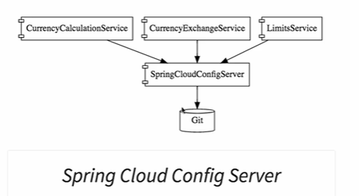

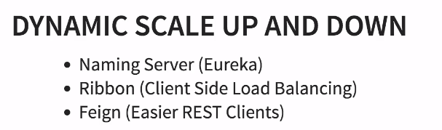

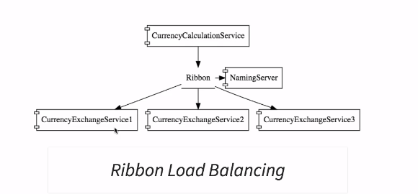

**Naming service**

Service registration

Service discovery

**Ribbon**

client side load balancing

**Feign Client**

Rest client

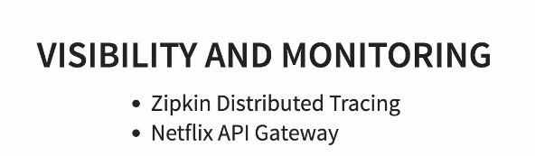



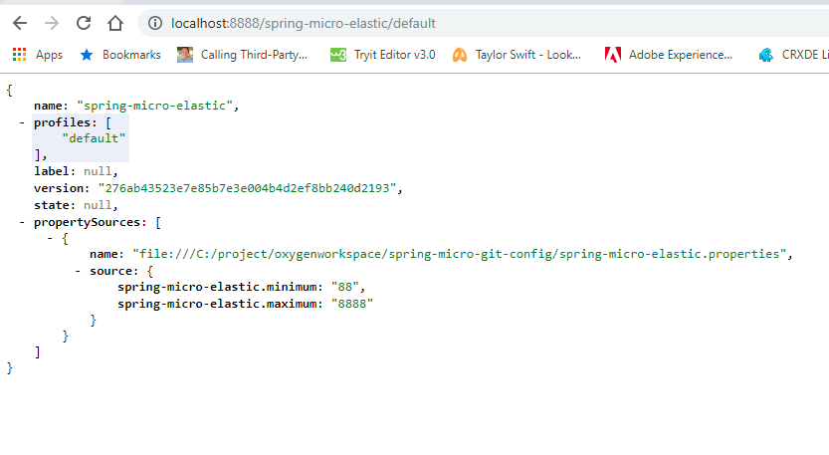

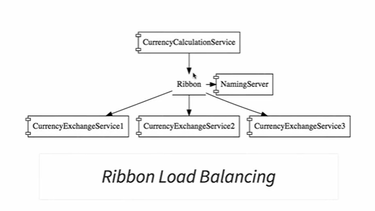

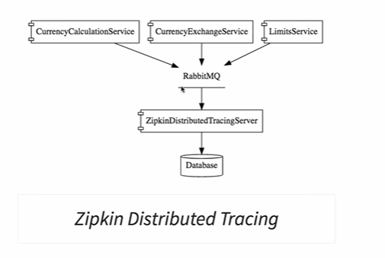

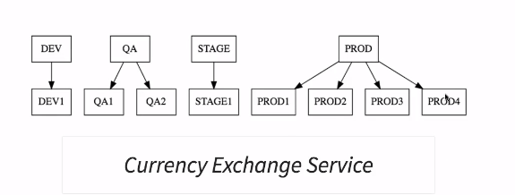

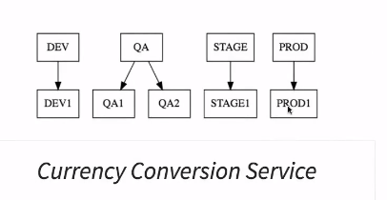

Ribbon helps in accessing services in load balanced way

Naming server is useful we need auto scale up or down. All the micro services will register themselves with the naming server (service registration) service1 contacts with naming server to find out how many instances of service2 are running currently.(this is called service discovery)

These should be done at api gateway level

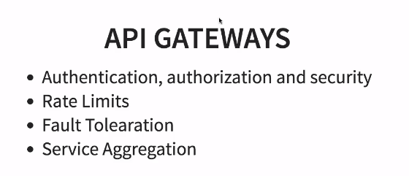

**Starting Cassandra NoSQL db**

C:\project\softwares\apache-cassandra-3.11.4\bin>cassandra –f